Pwyllgor Lles Llangrannog Welfare Committee
Minutes of a Meeting on Thursday 8 November 2018

1. Present: Kat Dawes, Clive Bullock, Paul Dawes, Cynyr Ifan, Ricky Rowsell, Gari Jones, Guto Jenkins, Pob Thomas, Adrian Brice

2. Apologies: Kate Reed

3. Minutes of the meeting on Thursday 11 October 2018 were agreed as correct. Proposed Clive, seconded Paul.

4. Matters Arising
4.1 (4.1) Defibrillator It will cost £480-500 for the defib to be mounted in a box outside. Cynyr will ask the Community Council to help with the cost, and if this is a correct estimate. Electricity is required to keep the box from freezing; the pine end of the Council-owned Gents toilets would allow this.

4.2 (4.2) The missing and too-bright streetlights issue. Ongoing with the Community Council.

4.3 (4.3) Green Flag Award. Ongoing.

4.4 (4.4) Llangrannog merchandise. Brynhoffnant Garage could be approached to sell these as well.

4.5 (4.5) Bottle bins and more frequent collection in carpark. Contact the Council early next year.

4.6 (4.6) Andy Gaunt will design the rubbish leaflet once it has been translated. The Community Council can only support this leaflet if we also produce information regarding dogs on the beach. Kat has written this (it has been posted up for the last two years) and will send to Cynyr for Community Council comment.

4.7 (4.7) Benches/Sianti cleanup. Ongoing.

4.8 (4.10) Pete and Jan Dobson leaving gift. Jane y Graig has been chosen to create a painting featuring the Shop. Cost to include framing. This should be done by the end of February.

4.9 (4.11) The road up from Pen Rhip. The Council sent a letter informing us that this road (the C1159) will be resurfaced by the end of the financial year. They also made some comments regarding the resurfacing, which were a reiteration of the letter sent to residents before the work began.

4.10 (4.12) Memorial garden plaque for Sandy Denny. Ongoing.

4.11 (5.1) Disputed area of land by the Ship Inn – this is common land. Ongoing.

4.12 (4.17) Bica Byw. No further information. Helena to find any documentation about previous Capel Crannog studies.

4.13 (5.2) The decking built over the stream next to Manorafon extends further than halfway. This is with solicitors.

4.14 (5.3) Jean Darbey passed away in July. Gerry will email Tanya re. having plaque. Ongoing.

4.15 (6.4) Invasive species. Himalayan Balsam can be pulled and left to die. Japanese Knotweed is best treated in spring via stem injection. Pob has a spraying licence and can work with five volunteers. We plan to tackle this in Feb/March.

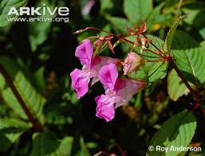
Himalayan Balsam
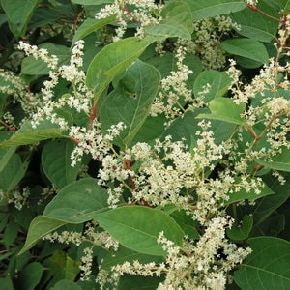
Japanese Knotweed

4.16 (6.5) Over 60s Christmas Dinner. 12th December, Pentre Arms. Jonathan Rees will play some carols.

5 Correspondence

6 AOB
6.1 Mari Lwyd – Jane Arrow proposes reviving this New Year tradition. We are keen to support. Ricky will ask about a horse’s skull.

6.2 Pen Rhip landslide. Warning tape has been put up. We will keep an eye on the situation; it may be that it needs proper fencing and signs. The volume of water coming through the drainage pipe caused overspill, but it is working.

6.3 Congratulations to Adrian Brice, soon to become a grandfather.

Meeting closed 9.05pm. Next meeting is 13 December, 7.30pm in the Pentre, to be followed by a few Christmas drinks in the Pentre and Ship.

