Pwyllgor Lles Llangrannog Welfare Committee
Special General Meeting – Coronavirus Measures in Llangrannog
14 May 2020 7.30pm via Zoom

Present: Cynyr Ifan, Kat Dawes, Paul Dawes, Helena Boyesen, Gerry Jones, Anne-Marie Bollen

With half term approaching and the changes to English regulations, there is more potential for visitors coming into the area. The Welsh Government has extended the lockdown by three weeks, which covers the half term holidays. We would love to welcome people – but not during this lockdown.

Informing visitors
What can we put in place to inform visitors of the Welsh regulations? What do we need to do? We have every right to ask people not to come into the village. The only thing we’ve been able to do with those who have come is report them, but once they’re here the police can’t do anything.

Bilingual notice on Facebook and llangrannog.org.uk on behalf of the Welfare. We will use the Govt wording. Posters for the noticeboards.

Contact Matt and Brad (PCSOs) to ask what they have in place and whay they recommend. We would like to see more signs up (Pentregat and Brynhoffnant) to reiterate that Llangrannog is closed. We will report visitors arriving at second homes to them.

Can we have sanitiser in the public toilets, and up at the car park? If the Council are unable to provide, we could look at doing this ourselves. Ask the toilet attendant what measures are in place at the moment.

Recommendations from organisations
Contact the main holiday rental agencies to reassure us that none of their properties are taking bookings. AirBnB properties are not able to take any bookings for dates before 1 July, unless they are for frontline workers. Gilfach/Greenfields etc.?

Can Ben Lake and Elin Jones give us any idea what the plans for the future are or any advice? What are the Visit Wales recommendations?

Reducing traffic, promoting the use of bikes and footpaths.
The beachfront car park – as planning permission has been granted, it could open and create a problem.

Lee Waters AM’s proposals for after lockdown – more cycle lanes, pavements, pedestrianisation, disabled access. We would like to capitalise on this. Cynyr has drafted a letter to send to the Council to ask them to express an interest. Sending to Eifion Evans and Gwyn James.

When the beachfront businesses open again, including Caiacs Carreg Bica and Tafell a Tân, we would like to work with the Council to restrict cars now and in the future to maintain the current peaceful atmosphere and safe space.

We could then promote the village as a place where you can socially distance and be safe. We need to consult businesses and residenrts. Access for deliveries and residents to be considered. This feeds back into the Welfare of Future Generations Act.

St Dogs have had a grant to plant lots of fruit trees. We would like to do that in the top car park with old Welsh stock trees from Gwynfor Growers. http://www.stdogmaelsabbey.org.uk/peoplesorchard

Widening community participation
With such a large proportion of properties being second homes and holiday rentals, we would like to involve the owners in important issues. A representative of the group could sit on the Welfare. We can send information, updates and the minutes of meetings. We need to be very positive and welcoming about this and make it a bonus for the owners.

Helena has created a list and has contact details for just about half of the owners and is working on finishing a map. Data Protection issues need to be taken into account, although much of the information is in the public domain.

We could organise a letter drop to invite people to join. We could ask Phil or another regular visitor and homeowner, and publicise the initiative on Facebook etc.

Next meeting 7.30pm Thursday 21 May via Zoom.

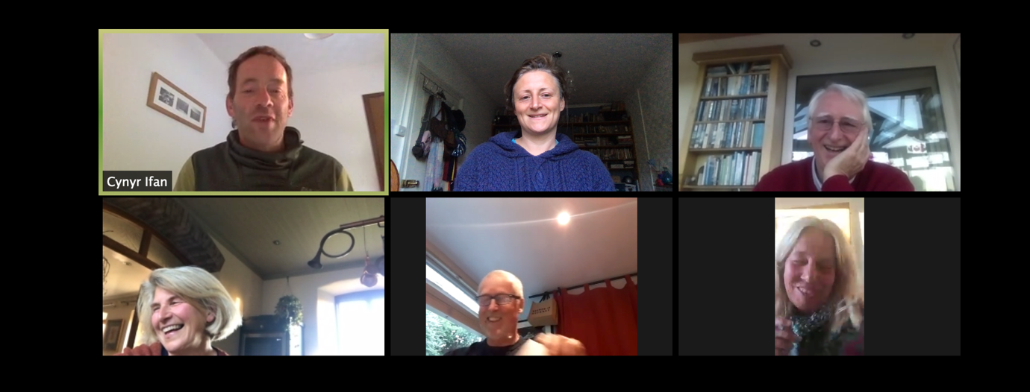

Kat
Cynyr
Cynyr
Helena/Anne-Marie
Helena
Kat
Cynyr
Helena/Anne-Marie

