Pwyllgor Lles Llangrannog Welfare Committee
Minutes of a Meeting on Thursday 14 February 2019

1. Present: Kat Dawes, Clive Bullock, Paul Dawes, Cynyr Ifan, Gari Jones, Guto Jenkins, Helena Boyesen, Anne-Marie Bollen, Gerry Jones, Adrian Brice, Pob Thomas.

2. Apologies: Kate Reed, Ricky Rowsell, Sioned Jones.

3. Minutes of the meeting on Thursday 13 December 2018 were agreed as correct. Proposed Gari, seconded Paul.

4. Matters Arising
4.1 (4.8) Jane Evans was invited to discuss her commission for a painting for Pete and Jan. We were shown a couple of options and approved a lovely view of the Shop, which Jane proposes to put into a special frame.

4.2 (4.10) Sandy Denny. Louise Burgess came to talk to us about Sandy Denny. Arguably the finest singer songwriter this country has produced, she was the first female songwriter to sign a record deal in her own right. Sandy’s uncle and aunt Les and Irene Jones and their daughter Hilary lived in the area, although it has been hard to exactly where.

Louise would like to see a plaque raised in the Memorial Garden, which would commemorate the importance of the village to Sandy, and also encourage visitors to the area, given the surge of interest in her life and work. Suggestions were made for further research e.g. the National Library and Jon MO Jones.

It was noted that the Community Council are talking about commemorating Cranogwen.

4.3 (4.1) Defibrillator The box has arrived. Possible locations: the Sianti facing the Beach Hut; a pole by the noticeboard.

4.4 (4.2) Missing streetlight (end of the carpark) and the too-bright streetlights. Ongoing with the Community Council.

4.5 (4.3) Green Flag Award. Ongoing.

4.6 (4.4) Llangrannog merchandise. We can look at a new design and different products once we know how much was sold. Helena will collect remaining goods and monies from the Beach Hut.

4.7 (4.5) Bottle bins and more frequent collection in carpark. To be picked up later in the season.

4.8 (4.6) The rubbish leaflet will include information about dogs on the beach. It will be a high-quality tri-fold with attractive imagery, suitable for posting on noticeboards and in houses.

4.9 (4.7) Benches/Sianti cleanup. Benches are waiting to be sandblasted.

4.10 (4.9) The road up from Pen Rhip (C1159) is due to be resurfaced; work beginning 1 April 18 March.

4.11 (4.11) Disputed area of land by the Ship Inn. There will be a retrospective planning permission application and people will be able to object if they feel the cameras, signage and parking meter are intrusive.

4.12 (4.12) Bica Byw. We will invite Helen Howells to speak at the AGM. We will help with a physical leaflet drop in the area. The next step for Capel Crannog is a survey.

4.13 (4.13) Manorafon decking – ongoing with solicitors.

4.14 (4.14) Jean Darbey. Tanya and Jaques like the idea of a Memorial Garden plaque and will give a decision in the summer.

4.15 (4.15) Invasive species. We plan to tackle this in March when it begins budding.

4.16 (6.2) Height/width/weight restrictions for the access roads to Llangrannog. Ongoing.

4.17 (4.16) The Mari Lwyd went out on 12 January and was a great success. Special mention to all the children who took part in the workshops and the night itself, and Jane for use of the Beach Hut.
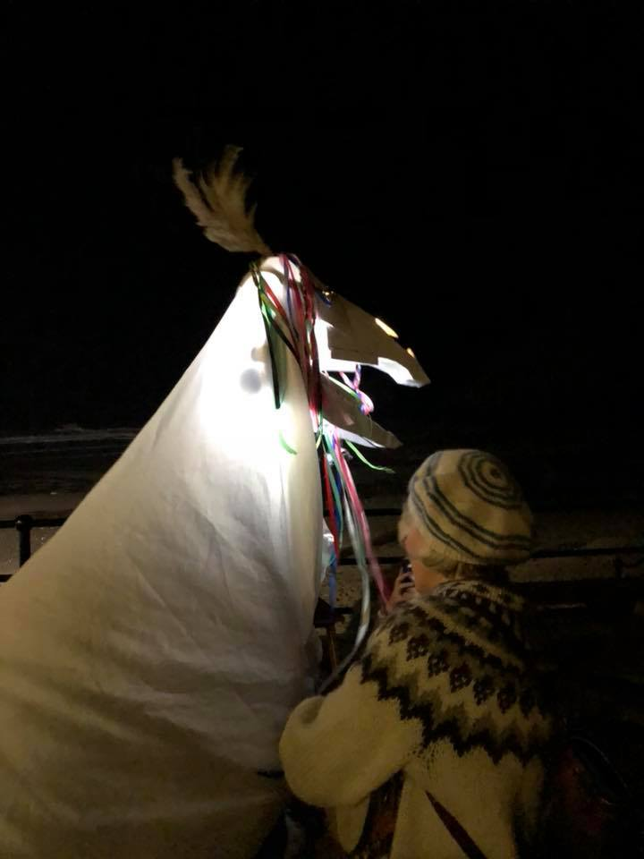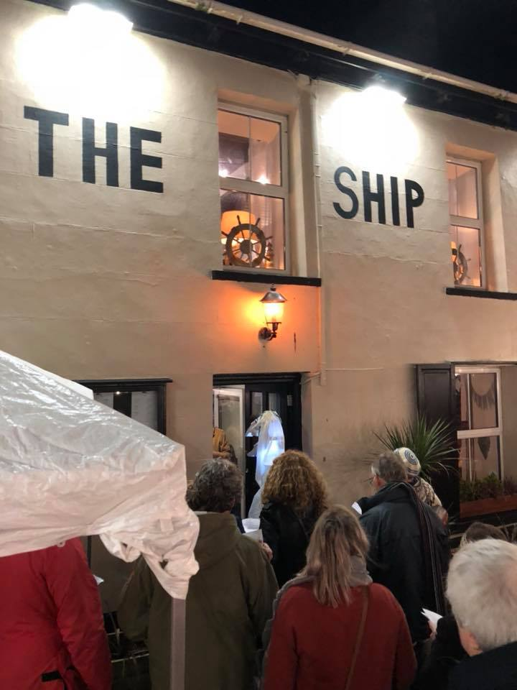

5 Correspondence
6 AOB
Meeting closed 21.02pm. Next meeting is 14 March, 7.30pm in the Pentre. AGM to be organised for Thursday 4th April.

