Pwyllgor Lles Llangrannog Welfare Committee
Minutes of a Meeting on Thursday 13 February 2020

1. Present: Kat Dawes, Clive Bullock, Cynyr Ifan, Gerry Jones, Adrian Brice, Helena Boyesen, Anne-Marie Bollen.
2. Apologies: Paul Dawes, Sioned Jones (retiring), Phil & Kelly Harris, Gari Jones.
3. Minutes of the meeting on Thursday 9 January were agreed as correct. Gerry, seconded Helena.

4. Matters Arising
4.1 (4.1) The rubbish leaflet. The Community Council are just finishing this off and it will be out very soon.

4.2 (4.2) Benches/Sianti cleanup. We will pay to get them sandblasted and back in place by Easter.

4.3 (4.3) Carpark by the Ship Inn.
Some people had problems submitting their objections. Some people received a letter about upholding their objections even though their objections were mostly about other aspects of the application. Many didn’t get this letter as the Council’s email server was not working.

Everyone is disappointed with the Council’s system and inability to answer basic questions about the process e.g. why the information about the flood risks were quietly removed from the application and why some people did not receive letters.

The Community Council would like to meet with a couple of Welfare members to explain our and their positions. It is probably too late now as the application will be moved forward very soon.

4.4 (4.4) Bica Byw. There is a drop-in night on 28 February 4-7pm in the Pentre for people to get an update on the project and to submit their ideas on what to do with the site at Capel Crannog. Everyone to please publicise.

4.5 (4.5) Invasive species. Ongoing.

4.6 (4.6) Planting perennials. Basil reckons it will only take a couple of days to rebuild the site by the phone box. He can re-use some of the stone but needs a ton more which Adrian can supply. Welfare funds can buy sand and cement.

There is a quiz on 21 February in Ship to raise money for this.

4.7 (4.7) Phone Box. No reply from the Council. Contact BT and ask what the options are.

4.8 (4.8) Lôn Cati sign. Technical Services have been contacted about replacing the sign and we have asked for something to direct people to the beach not down Lôn Cati.

4.9 (4.9) Cilborth railings. Enquire about the status of this.

4.10 (4.11) Village and beach info sign (next to the Hawen outfall) Ask Cliff Bates if he can help replace the perspex and update the information, and if we could maybe take control of it.

4.11 (5.1) Cranogwen. Ongoing.

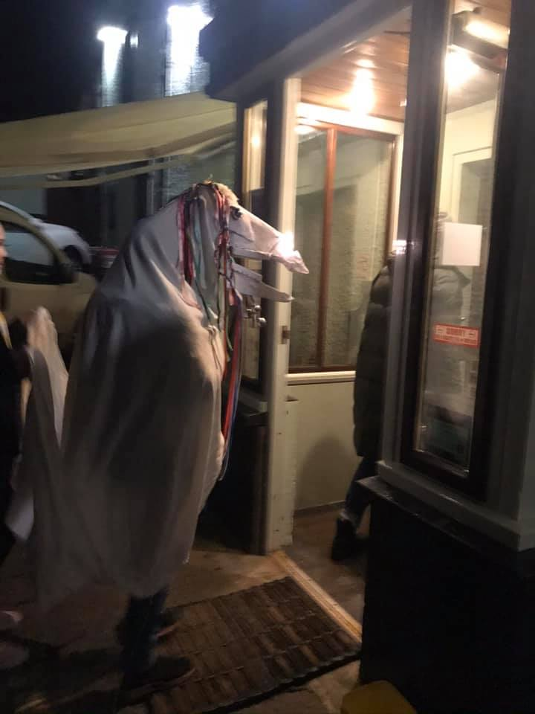
4.12 (6.1) Renewable Energy. There are possibilities but the problem is the connection into the grid. Helena met some experts. Our nearest sub-station is Aberporth. The next is Aberaeron. We are at the end of one ‘tentacle’. In that radius you can form a group of 40 who wanted to buy into ‘octopus energy’; you would be buying the locally created energy which can come from anyone with small power generators e.g. a turbine. Wind generation tends to produce better electricity here. If you use the local electricity while it is being generated you have a cheaper rate. We would like to get Renewable Wales to come down and speak to us about all this.

4.13 (7.1) Mari Lwyd – Ran on 18th January. We need to organise more around this next year and gather more interest especially from the youngsters.

(4.14) 7.1 Parking alternatives. The Transport Committee are checking out a possible minibus. Ongoing.

5. Correspondence
5.1 Sioned Jones is leaving the Committee due to work commitments on Thursday nights. We thank her for her contribution over several years.

6. Community Council Report
The car park issue was discussed, as above. The phone box issue was also discussed.

7. AOB
7.1 New defibrillator pads have been bought.

7.2 Helena sent a card to Susan Kean’s mother on behalf of the Welfare Committee. A sad and sudden loss to the community, Susan was very active as part of the Hall committee.

7.3 Boat Yard Commemorative Bench. Mickey would like to make a bench to commemorate Alban Davies and the fishermen over the years. We can hep to raise money for this. It would also be good to record their histories.

7.4 Rights of Way. It is believed that there is an ancient right of way through the Ship carpark. Old maps and pictures would be useful to prove it.

Other paths: one through the boatyard, one at the end of Helena’s, and one from Lochtyn drive to Cilborth steps. We want to make sure these are preserved for the community.

Helena and Paul have produced a pack to help people support an application to get them registered. This will be translated.

Meeting closed 20.33pm. Next meeting is Thursday 12th March, 7.30pm, Ship.

