Contact: Dr Kat Dawes,
Secretary,
Llangrannog Welfare Committee,
Ty Capel Crannog,
Llangrannog
Llandysul
Ceredigion
Email: kldawes@gmail.com
November 2020

Llangrannog Welfare Committee

Securing our Rights-of-Way

We all take for granted (not unreasonably) our right to use the paths around Llangrannog. However, if the rights-of-way are not registered this can cause problems both for those who use the paths and for landowners. To secure rights-of-way it is necessary to apply to the Council for “The modification of the Definitive Map and Statements of Public Rights of Way” for each footpath or highway.

We have already done the necessary preparation for this. Now we ask that you complete a simple form (Form D “Supporting Statement”) for each path with as much evidence as you have, assuming that you do have experience of the routes described. You should add to the final section entitled “Any other Information” any specific experience or evidence. In particular you may have a different view of the route or path shown on the maps – you are free to amend any aspect of the forms. If you have some evidence that you believe to be significant then please make contact with us.

We have two routes which we want to process first. The footpath from Lochtyn drive to Cilborth steps and the route through the Ship car park. Please take you time with the latter and provide your perspective, particularly whether you see it as a footpath / bridleway / restricted byway or whether you see it as a byway that has always been open to all traffic to the beach.

If you wish to secure these rights-of-way you will make a significant difference by completing these Forms and sending them to the address provided below, for onward transmission to the Council.

Thank you,

Llangrannog Welfare Committee.

Address to send the completed forms:
Dr Kat Dawes, Secretary, Llangrannog Welfare Committee, Ty Capel Crannog,
Email address for contact: kldawes@gmail.com

Attachments:

2. Form D claim public right of way FROM LOCHTYN DRIVE TO CILBORTH STEPS
3. Form D claim public right of way SHIP CAR PARK

FORM D

SUPPORTING STATEMENT CLAIMING A PUBLIC RIGHT OF WAY
IMPORTANT NOTE: The object of this inquiry is simply to reach the truth of the matter whatever it may be. Witnesses are therefore asked to answer the questions as fully as possible and not to leave out any relevant information, whether for or against the claim. This is of particular importance if the information is to be of real value in establishing the status of the way.

Name (CAPS) Mr/Mrs/Miss ………………………………………………………………….
Address (CAPS) ………………………………………………………………………………
………………………………………………………………………………………………….
Occupation …………………………………………………………………………………….
Route of path …FROM LOCHTYN DRIVE ROADWAY TO THE COASTAL PATH BY CILBORTH STEPS - AS SHOWN ON THE ATTACHED MAP AND PHOTOGRAPH
1. Do you regard the route to be a public footpath*/ bridleway*/restricted byway/byway open to all traffic*? FOOTPATH
[Footpath – used by the public on foot only, Bridleway - used on foot and on horseback, Restricted Byway – used on foot, horseback and in non-motorised vehicles, Byway Open to All Traffic - used on foot and on horseback and in motorised vehicles.] * Delete as appropriate
1. Do you regard the route to be a public footpath?
[Footpath – used by the public on foot only]
2. | Do you regard this route as public? |  | 3. | Have your friends or family regarded it as public?
4. | How many years have you known the route? | ……………. | 5. | During which years have you used the route? | …………….
6. | For what purpose did you use the route (pleasure, going to work, shops, etc)? |  | 7. | How frequently did you use the route (daily, monthly etc.)? | …………….

8. How have you used the route (on foot, on horseback, in vehicles)?
9. Has the route ever changed? …
10. Have you ever known any stiles/gates/notices/locked barriers along the route? If so, give
particulars of dates, locations etc. …THERE IS A STILE AT TOP OF THE FIELD AND A KISSING-GATE AT THE BOTTOM.
11. Have you ever been stopped or turned back when using the route? …
12. Have you ever asked permission to use the route? …
13. Have you ever had any connection with the land crossed by this route (owner / tenant /
employee)? If so give details /dates. …
Any other information (if necessary continue on additional sheets)
………………………………………………………………………………………………………………………………………………………………………………………………………………………………………………………………………………………………………………………………………………………

I hereby declare to the best of my knowledge and belief the facts set out are fully and truly stated. I am not aware of any other facts or documents which should be brought to the attention of the registration authority as likely to affect its decision on the application. I understand that the information I provide, including name & address will be included in reports etc. and made available to the public ,relevant landowners and consultants working on behalf of Ceredigion County Council during the investigation process (telephone numbers and signatures will be redacted)I am willing to attend a hearing or public inquiry to give evidence on this matter, if this should prove necessary.

Signed ……………………………………………. Date ……………………………..

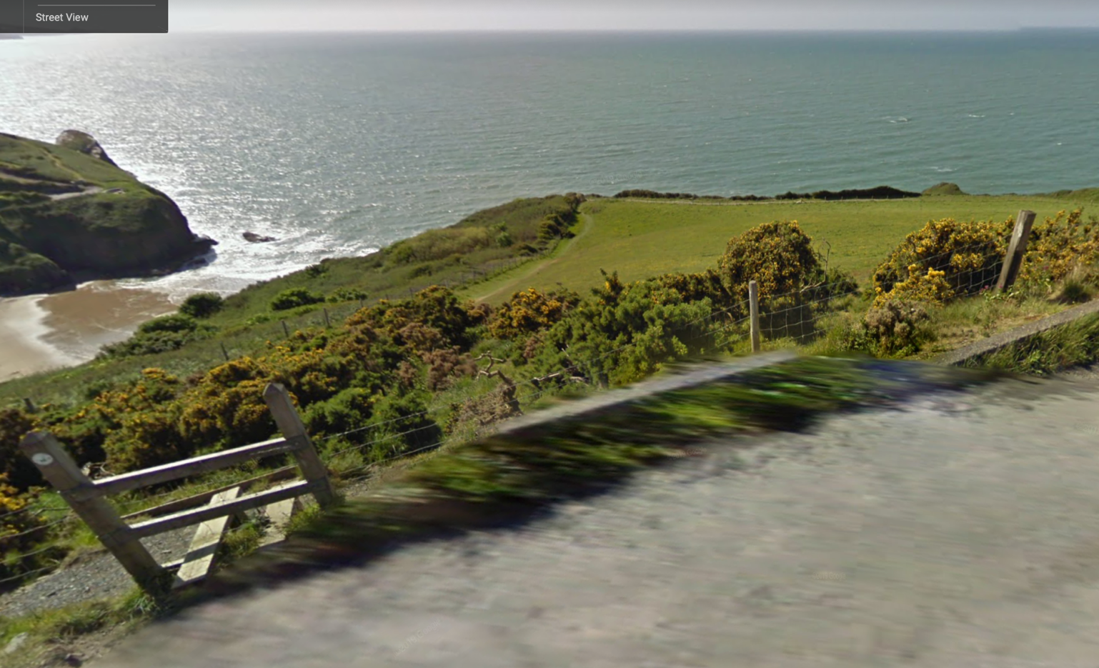

FORM D

SUPPORTING STATEMENT CLAIMING A PUBLIC RIGHT OF WAY
IMPORTANT NOTE: The object of this inquiry is simply to reach the truth of the matter whatever it may be. Witnesses are therefore asked to answer the questions as fully as possible and not to leave out any relevant information, whether for or against the claim. This is of particular importance if the information is to be of real value in establishing the status of the way.

Name (CAPS) Mr/Mrs/Miss ………………………………………………………………….
Address (CAPS) ………………………………………………………………………………
………………………………………………………………………………………………….
Occupation …………………………………………………………………………………….
Route of path:
THROUGH ‘SHIP CAR PARK’ TO THE BEACH AND ACROSS THE CAR PARK TO PATIO CAFÉ AS SHOWN ON THE ATTACHED MAP AND PHOTOGRAPHS
1. Do you regard the route to be a public footpath*/ bridleway*/restricted byway/byway open to all traffic*? * Delete as appropriate
[Footpath – used by the public on foot only, Bridleway - used on foot and on horseback, Restricted Byway – used on foot, horseback and in non-motorised vehicles, Byway Open to All Traffic - used on foot and on horseback and in motorised vehicles.]
2. | Do you regard this route as public? |  | 3. | Have your friends or family regarded it as public?
4. | How many years have you known the route? | ……………. | 5. | During which years have you used the route? | …………….
6. | For what purpose did you use the route (pleasure, going to work, shops, etc)? |  | 7. | How frequently did you use the route (daily, monthly etc.)? | …………….

8. How have you used the route (on foot, on horseback, in vehicles)? …………………
9. Has the route ever changed?
10. Have you ever known any stiles/gates/notices/locked barriers along the route? If so, give
particulars of dates, locations etc. ……
11. Have you ever been stopped or turned back when using the route?
12. Have you ever asked permission to use the route?
13. Have you ever had any connection with the land crossed by this route (owner / tenant /
employee)? If so give details /dates.

Any other information (if necessary continue on additional sheets)
………………………………………………………………………………………………………………………………………………………………………………………………………………………………………………………………………………………………………………………………………
………………………………………………………………………………………………………………………………………………………………………………………………………………………………………………………………………………………………………………………………………………………………………………………………………………………………………………………………………………………………………………………………………………………………………………………………………………………………………………………………………………………………

I hereby declare to the best of my knowledge and belief the facts set out are fully and truly stated. I am not aware of any other facts or documents which should be brought to the attention of the registration authority as likely to affect its decision on the application. I understand that the information I provide, including name & address will be included in reports etc. and made available to the public ,relevant landowners and consultants working on behalf of Ceredigion County Council during the investigation process (telephone numbers and signatures will be redacted)I am willing to attend a hearing or public inquiry to give evidence on this matter, if this should prove necessary.

Signed ……………………………………………. Date ……………………………..

This map shows the routes (between the ‘Xs’) from the road and across the car park to the beach. Please mark what you believe to be the appropriate routes from your experience.

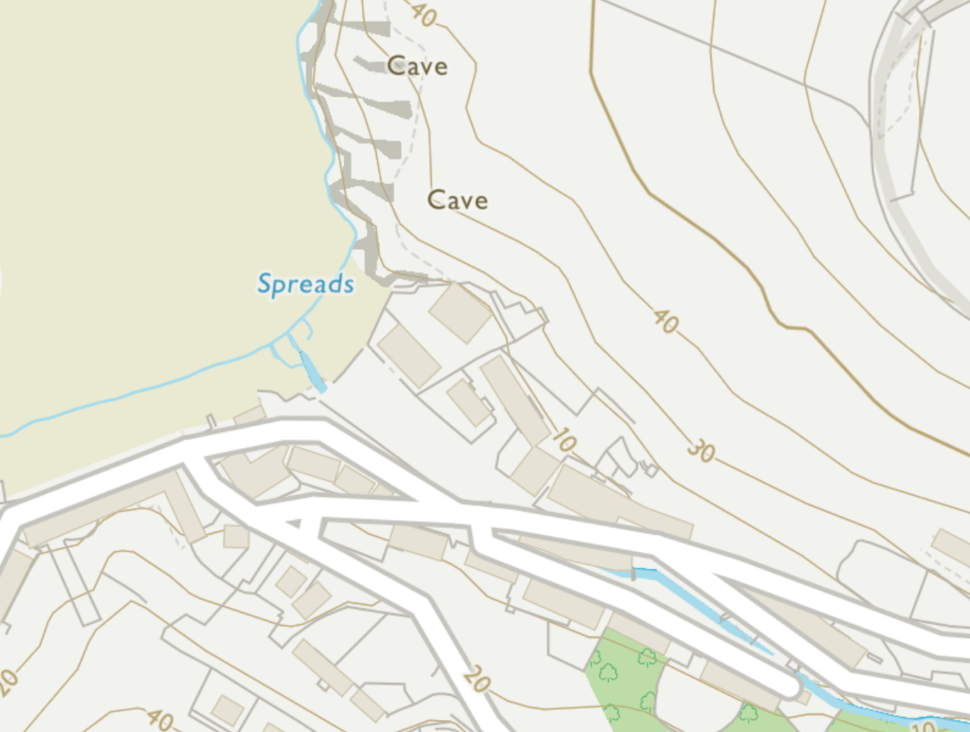
Patio
X
X
X
BEACH
The Ship

These photographs from the early 1900s show the village, before the culvert and road, when the route to the beach was through what is now the car park.
