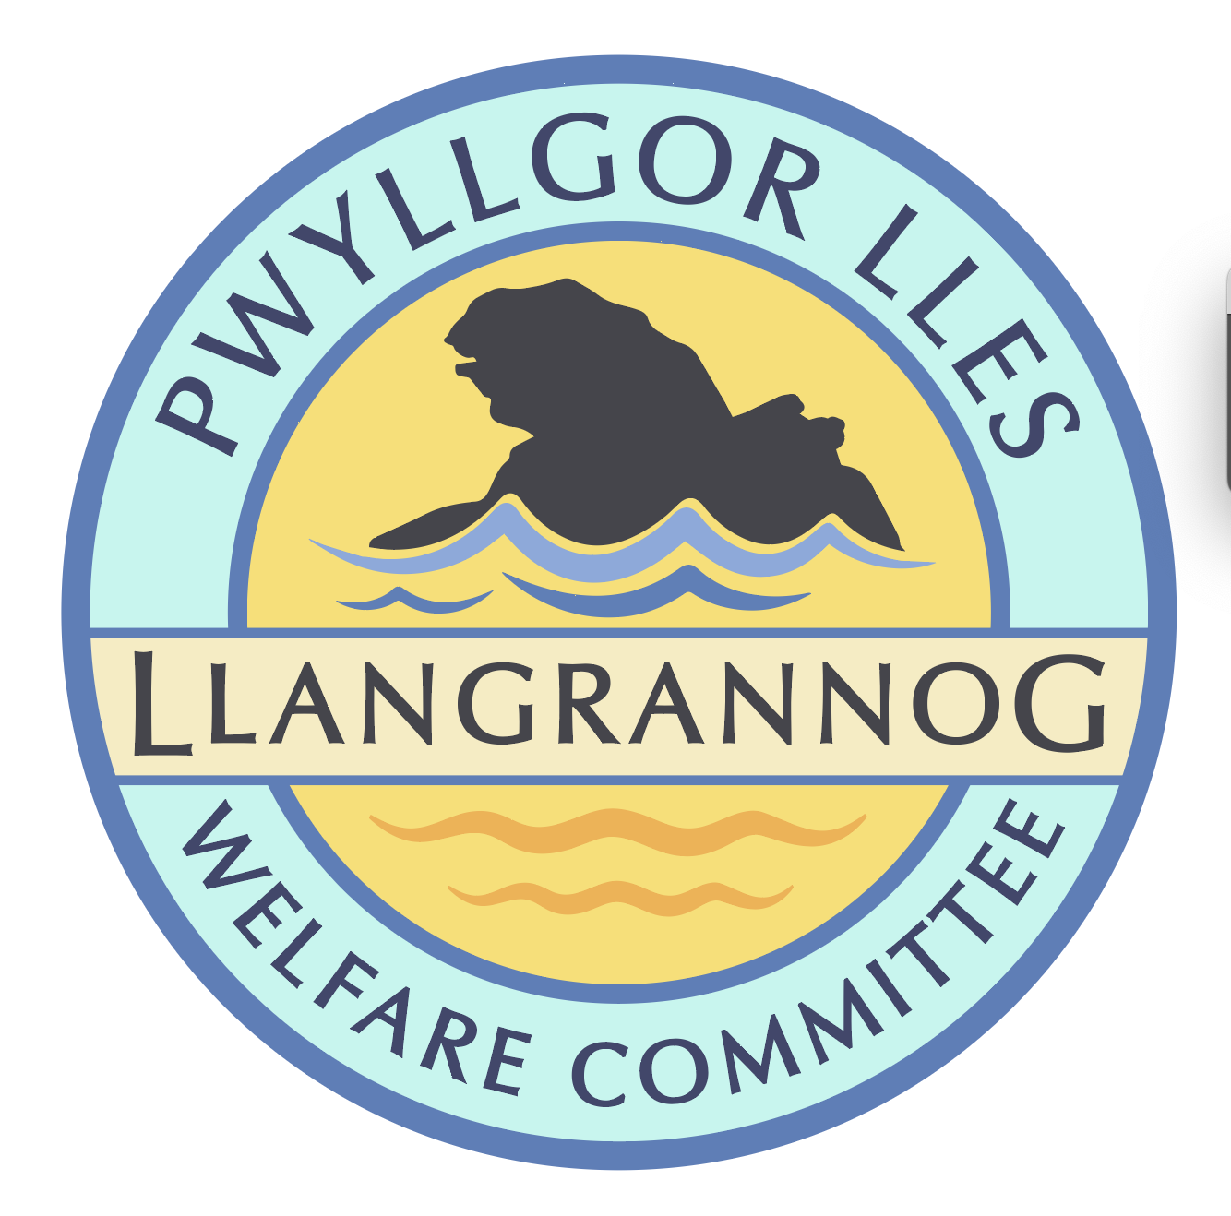

**Notes from the General Meeting of the**

**Pwyllgor Lles Llangrannog Welfare Committee**

**Thursday 8 May 2025**

**(short meeting following the AGM)**

**1. Present**: Kat Dawes, Tracey Rix, Jane Lindop, Gerry Jones, Jez Rix, William Riley, Gari Pwyll, Adrian Brice, Paul Dawes, Pob Thomas, Sam Wilmott, Vinny Vincent, Clive Bullock, Gail Robinson, Helena Boyesen, Cynyr Ifan.

**2. Apologies:** None. Minutes of the April meeting were agreed as correct.

**3. Notes/Items for June Agenda**

**Village Youth Party** Sunday15 June.

Possible sponsors:

* Marc Londis
* Boat Club
* Dewi James
* Castell Howell?
* Gwersyll – flyers and printing

**Barometer** on end of Siop Glynafon. It is an old RNLI tribute which was donated by someone to the community. Donation box next to it for RNLI? It requires maintenance. Ask Phil/Sue Hafod what they know about it.

**Replacement bench** for one burnt by a disposable barbeque in the top car park field.

**Railings** by lower Hawen again.

*The meeting closed at 21:43*

*Next meeting – 12 June, 7:30pm Pentre Arms*