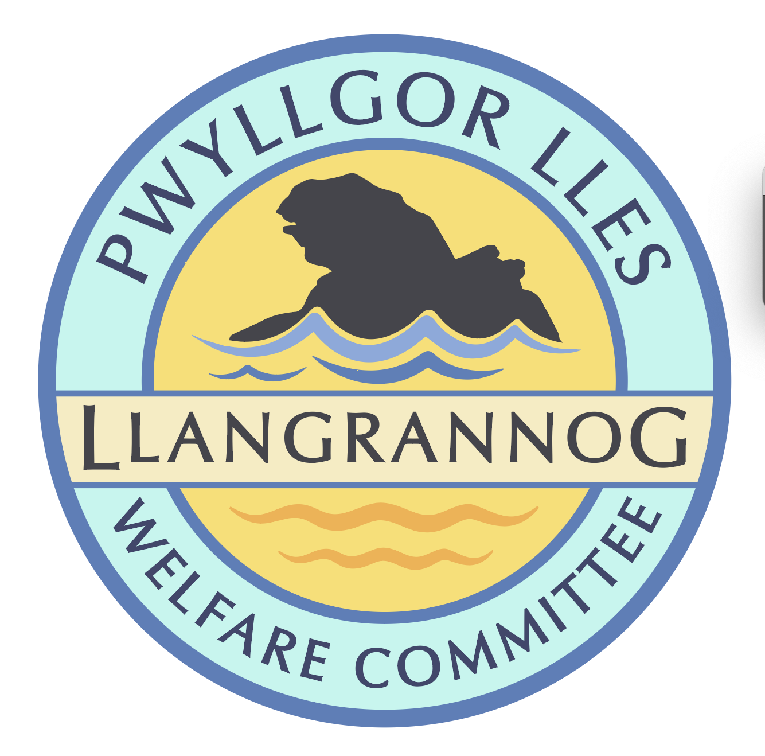

**Minutes of the Meeting of the**

**Pwyllgor Lles Llangrannog Welfare Committee**

**Thursday 10 April 2025**

**1. Present**: Kat Dawes, Tracey Rix, Jane Lindop, Gerry Jones, Jez Rix, William Riley, Gari Pwyll, Adrian Brice.

**2. Apologies:** Paul Dawes, Pob Thomas, Sam Wilmott, Vinny Vincent, Clive Bullock, Gail Robinson.

Minutes of the March meeting were agreed as correct.

**3. Notes arising from Minutes of the March meeting**

**3.0 Pontgarreg Field** One wooden bench is broken; will be fixed and returned to the PG Hall as requested.

**3.1 (4.1)** **Risk assessments.** Christmas Tree and lime kiln to be done.

**3.2 (3.4)** **Rubbish**. Collections seem to be intermittent at the moment. Ask Paul Edwards/Pob about new bins (inc dog bin). We can think about options if the service is unacceptable – removing the rubbish ourselves, delivering it to the Council offices! Posters on behalf of the community to say please take rubbish home – ask T Llew.

**3.3 (3.5) Friends of Llangrannog.** Pin badges have been made for people who donate. JR is printing some info to share soon. Beer mats ongoing.

**3.4 (3.6) Duck race** Easter Sunday 20 April. Ask Carys for the SumUp. Spare ducks. Hook-a-duck ready. **A**sk Londis for egg donations.

**3.5 (3.7)** **Lime Kiln/Boatyard**. No planning decision. We note that there is still rubbish left on the upper boatyard.

**3.6 (3.9) Y Gerwn.** The wall has been fixed and looks great.

**3.7 (3.10) Railing** missing. Also done very quickly. Letter to Highways to thank them – Clic.Railings on the slipway – someone has driven into them; inspect and report.

**3.8 (3.11) Flags** Wales flag – Jane L has a flagpole.

**3.9 (3.12) Car park** As long as you have paid you will not be fined (according to the OPS guy). The machine broke on Mother’s Day; contacted OPS – no reply but the cameras have been moved onto a pole and the machine and signs fixed. Is there planning permission for the pole? Do they need it?

To have an ANPR camera you need to follow the new code of conduct, according to the OPS guy? No signs to give people any new information.

**3.10 (3.13) Cranogwen/Garden info boards** Cranogwen group discussed content of info board. Seb and Helena are designing. (Kiln and well next!)

**3.11 (4.1) Information boards** – ask Lowri if they have plans to replace. Ask Nigel Nicholas (coastal path).

**3.12 (4.2) Village BBQ/event** Ongoing.

**3.13 (4.3) ‘Back lane’** Welsh name for the little lane by the Hawen. Ask Ian what it might be. John Page could not find anything.

**3.14 (4.4) Connect Ceredigion** garden filming – ongoing.

**3.15 (4.6) Ffynon Fair.** Gate and railings could be installed.

**4. AOB**

**4.1 Permit** only spaces for residents without parking e.g. opposite Banc-y-Felin Vestry. Would the Council consider this for certain areas?

**4.2** **Outfall pipe** has been damaged and broken off. It is treated water and should be safe, except when there is an overflow incident.

**4.3 Hwb** – Noted that people asking about Welfare related issues don’t always get a quick answer. Ask Louise to keep us updated (and less adverts).

*The meeting closed at 21:43*

*Next meeting – AGM 8 May, 7:00pm Beach Hut*