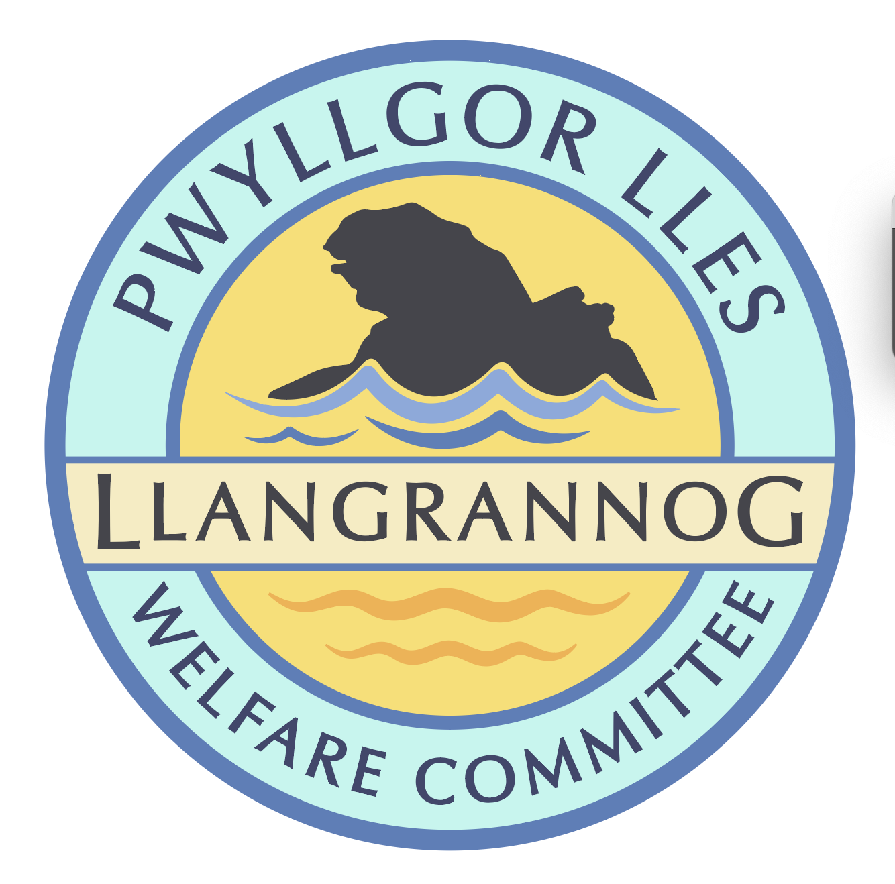

**Minutes of the Meeting of the**

**Pwyllgor Lles Llangrannog Welfare Committee**

**Thursday 12 June 2025**

**1. Present**: Kat Dawes, Tracey Rix, Jane Lindop, Gerry Jones, William Riley, Gari Pwyll,. Paul Dawes, Sam Wilmott, Clive Bullock, Jez Rix.

**2. Apologies:** Vinny Vincent, Gail Robinson, Adrian Brice, Pob Thomas.   
Minutes of the April meeting and notes from May were agreed as correct.

**3. Notes arising from Minutes of the April/May meetings**

**3.0 Pontgarreg Field** Repair benches and let Pontgarreg Village Hall know they can have one.

**3.1 Risk assessments.** Christmas Tree and lime kiln to be done. Check list and assign/reassign.

**3.2** **Rubbish**. Collections have been regular. Send a thanks for better litter collection; ask for update on Paul Edwards’ plans for a larger bin for the summer holidays.

**3.3 Friends of Llangrannog.** Send info to share with potential donors. Information for Facebook/websites etc. which isn’t just asking for money. Short video updates on things the money will be paying for/already have been achieved, explained by members who are part of a particular project e.g. Garden, benches, orchard. Businesses have had an info pack which we need to follow up on. Window stickers will be made; we have some funds for this.

**3.4 Duck race.** August Duck Race – discuss in July meeting.

**3.5 Lime Kiln/Boatyard**. No planning decision yet.

**3.6 (3.7) Railing** on the slipway – someone has driven into them.

**3.7 (3.8) Flags** Wales flag – assess possible flagpole.

**3.8 (3.9) Car park** Ongoing.

**3.9 (3.10) Cranogwen/Garden info boards** Ongoing.

**3.10 (3.11) Information boards** – ask Lowri if they have plans to replace. Ask Nigel Nicholas (coastal path).

**3.11 (3.12) Village BBQ/event** Sunday 15th BBQ for local kids; adults can join and donate a bit. Mark Webb is donating sausages and we will buy soft drinks buns etc. BYO drinks.

**3.12 (3.13) ‘Back lane’** Lôn Morwen was suggested. Ask the Council if they have a name or how we’d get one.

**3.13 (3.15) Ffynon Fair.** Gate and railings could be installed.

**3.14 (4.1) Permit** only spaces for residents without parking e.g. opposite Banc-y-Felin Vestry. Would the Council consider this for certain areas?

**3.15 (4.2)** **Outfall pipe** has been damaged and broken off. It is treated water and should be safe, except when there is an overflow incident. Gerry has reminded Dŵr Cymru.

**3.16 (4.3) Barometer** on end of Siop Glynafon. We have had a history document from Phil and Sue Hafod. Donation box next to it for RNLI? It requires maintenance and possibly a restoration. We need to check if it’s working.

**3.17 (4.4) Replacement bench** for one burnt by a disposable barbeque in the top car park field. GJ will try a repair.

**3.18 Community Council Update:** Public toilets closure threat. We will attend a meeting with the Community Council to discuss how we can help.

**4. Agenda Items**

**4.1 River Hawen pollution**

**4.2 Path to St Crannog’s Cave:** Discuss again.

**4.3 Dog signs:**Picture send around. Price up sign.

**4.4 Bench above Carreg Bica**: Price up. Clive has original plaque. Local sawn oak would be hardy. **F**ind out who made Deio’s bench.

**4.5 Footpath** across field from Rhiw Gam junction over to Lôn Cati needs strimming and the bridge is broken.

*The meeting closed at 20:30 Next meeting – 10 July, 7:30pm Pentre.*