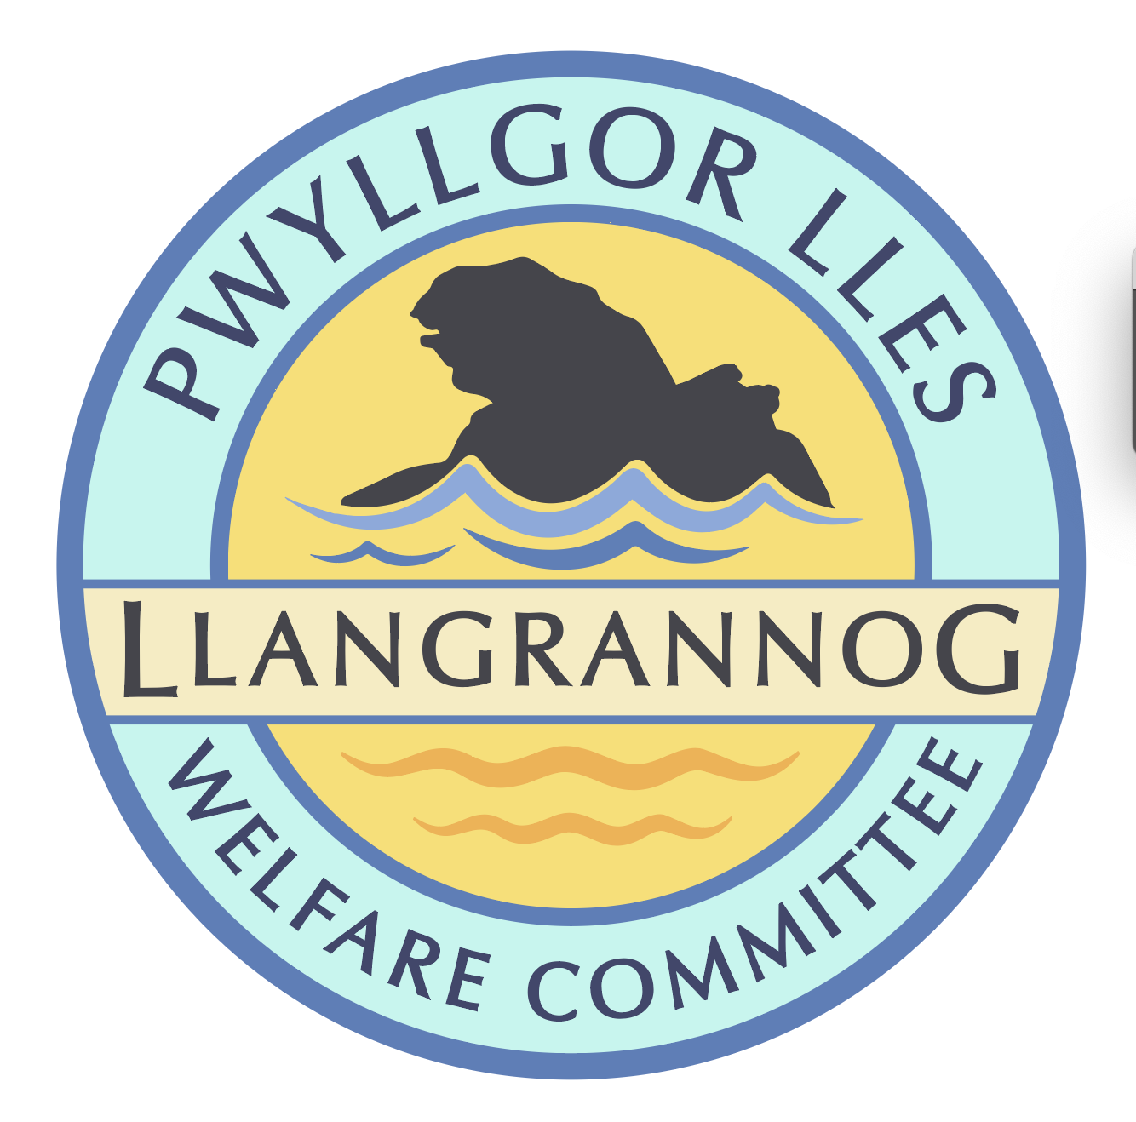

**Minutes of the Meeting of the**

**Pwyllgor Lles Llangrannog Welfare Committee**

**Thursday 17 July 2025**

**1. Present**: Kat Dawes, Tracey Rix, Jane Lindop, Gerry Jones, William Riley, Gari Pwyll, Paul Dawes, Sam Wilmott, Clive Bullock, Jez Rix, Gail Robinson, Adrian Brice, Helena Boyesen.

**2. Apologies:** Vinny Vincent, Pob Thomas, William Riley.   
  
Minutes of the June meeting were agreed as correct.

**3. Notes arising from Minutes of the June meeting   
3.0 Pontgarreg Field.** Gerry has repaired the benches. One will be delivered to Pontgarreg Village Hall.

**3.1 Risk assessments.** Christmas Tree and lime kiln to be done. GP check list and assign/reassign.

**3.2** **Rubbish**. Second homes and rentals are/are not having collections and are unsure what they are supposed to do. They should find out themselves, but also the Council are not helping them to understand their responsibilities. We could post something on the Hwb to inform people where they can find the information. And contact Paul Edwards to suggest they put out up-to-date information.

**3.3 Friends of Llangrannog. JR**[1] to send info to share with potential donors. Information for Facebook/websites etc. which isn’t just asking for money. Short video updates on things the money will be paying for/already have been achieved, explained by members who are part of a particular project e.g. Garden, benches, orchard. Businesses have had an info pack which we need to follow up on. Window stickers will be made; we have some funds for this.

**3.4 Duck race.** Clive, Jane, Tracey. Others can help. Sunday 24th. Poster.

**3.6 (3.7) Railing** on the slipway – someone has driven into them. No news.

**3.7 (3.8) Flags** Wales flag. We are welcome to have Jane’s flag pole if it can be removed.

**3.9 (3.10) Cranogwen/Garden info boards** HB and Seb have nearly finished it.

**3.10 (3.11) Information boards** Ask Lowri if they have plans to replace. Ask Nigel Nicholas (coastal path).

**3.11 (3.12) Village BBQ/event** Sunday 15th BBQ. Lovely community event. Thanks to Mark Webb for sausages. We made over £400 for the Welfare. It would be nice to have another one September 20/21.

**3.12 (3.13) ‘Back lane’** Lôn Morwen was suggested. Ask the Council if they have a name or how we’d get one.

**3.13 (3.15) Ffynnon Fair.** Gate and railings could be installed. Measure up with the spare gate from village garden.

**3.14 (4.1) Permit** only spaces for residents without parking e.g. opposite Banc-y-Felin Vestry. Clive from CCC – they do issue parking permits so it might be possible.

**3.15 (4.2)** **Outfall pipe** has been damaged and broken off. It is treated water and should be safe, except when there is an overflow incident. Another 12ft has come off since first reported. It is visible at low tide.

If there are flash floods and the overflow runs, it will discharge onto the beach while the tourists are here. This should be far more of an issue than it is treated as.

We could all report this individually and ask the businesses to report and complain.

**3.16 (4.3) Barometer** It is working. Needs the wood rubbing down and oiling.

**3.17 (4.4) Replacement bench** for one burnt by a disposable barbeque in the top car park field – GJ has replaced the wood.

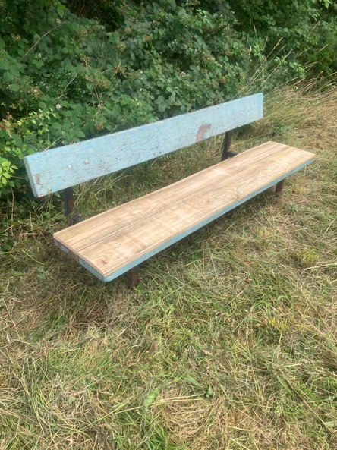

**3.18 Toilets:** We joined a meeting with the Community Council. We did not reach a consensus. The Community Council have said no, they cannot take it on for several reasons.

It’s unlikely Llangrannog will be made a priorty and given special treatment. Llangrannog has to be careful not to shoot ourselves in the foot. We cannot do a deal with them; they do not answer questions from the Community Council.

The Urdd camp will not be able to bring people down at all.   
There will not be a single disabled toilet in the village.   
And so many other points.   
  
Public meeting idea was to make sure people know about this and no-one says, why were we not told. We now feel it would be better to send out leaflets, have info on websites and social media and posters. Everyone needs to know about it – we can all talk to people about it. A single point of information from the CC/Welfare – factual. Online, posters, flyer with a single consistent message.

We must make sure people understand that our particular Community Council are not suited to running this (even if other CCs are doing it): manpower, capacity and the increase in the precept would be unviable.

Speak to Ben Lake and Elin Jones. Speak to Lowri at the Camp again.  
Create petition for Ceredigion County Council.

**4. Agenda Items  
4.1 River Hawen pollution** Jane Green reported possible pollution incident. Monitor.

**4.2 Path to St Crannog’s Cave:** Ask Pob.

**4.3 Dog signs:**Picture send around. Price up sign.

**4.4 Bench above Carreg Bica**: Clive has original plaque. Local sawn oak would be hardy. Deio’s bench was made by the Council. The information board has also broken. Ask for a price.

**4.5 Footpath** across field from Rhiw Gam junction over to Lôn Cati needs strimming and the bridge is broken.Fixed (Steve) and strimmed (PD).

**5. Any Other Business**

**5.1 Village Garden sign**. Pete wants a sign for Jan for the Garden. Welfare will pay for it as a tribute.

**5.2 Path** from above Carreg Bica to the Lochtyn layby has signs re. formal adoption of footpath by the Council. There are lots of new paths being formally incorporated.

**5.3 Toilets**: Sanitary waste has been dumped in the old rubbish shed. We have reported it but had no reply.

*The meeting closed at 20:30 Next meeting – 11 September, 7:30pm Pentre.*

1. **JR** text for FoL updates