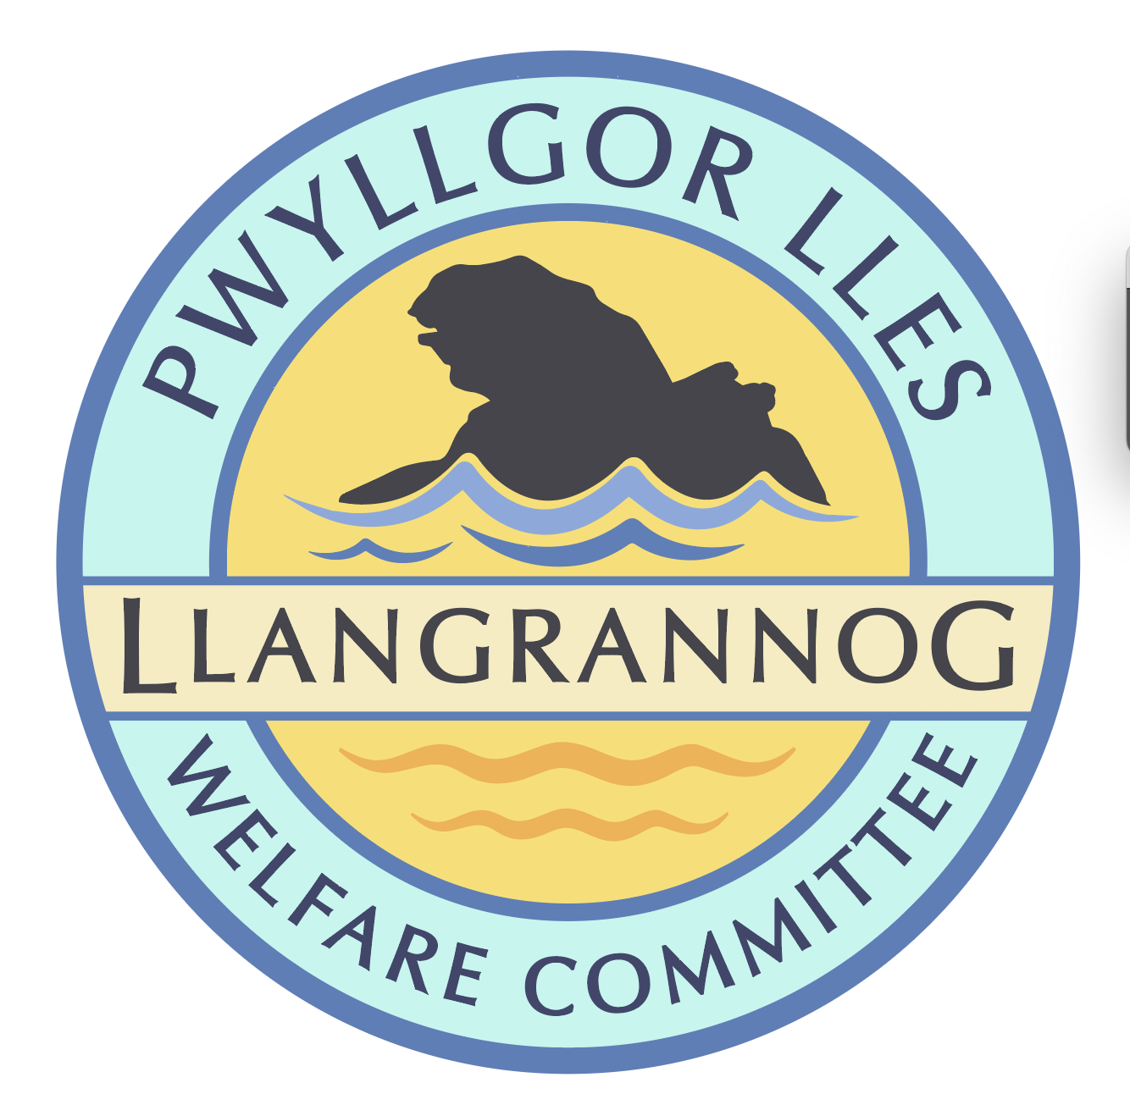
Minutes of the Meeting of the
Pwyllgor Lles Llangrannog Welfare Committee
Thursday 11 September 2025
1. Present: Kat Dawes, Tracey Rix, Jane Lindop, Gerry Jones, Gari Pwyll, Paul Dawes, Clive Bullock, Jez Rix, Gail Robinson, Adrian Brice, Helena Boyesen, Cynyr Ifan
2. Apologies: William Riley, Pob Thomas
Minutes of the July meeting were agreed as correct. (No meeting August.)
3. Notes arising from Minutes of the July meeting
3.0 Pontgarreg Field. Move a Field bench to PG Hall.
3.1 Risk assessments. Christmas Tree and lime kiln to be done.
3.2 Rubbish. Usual mess over the summer with people leaving bags out on the wrong days or not having a collection. Holiday homes should find out what to do, but also the Council are not helping them to understand their responsibilities. Contact Paul Edwards to suggest they put out up-to-date information at least once a year.
Beach collection has been regular and works pretty well. Street (Big Belly) bins are (according to the person emptying them) owned by Community Council who have an arrangement with the Council to empty them but not to clean them. They are full of gunge, attracting wasps and smelling bad.
3.3 Friends of Llangrannog. There have been quite a few donations especially linked to events/campaigns.
3.4 Duck race. Made just over £500 and ran out of ducks 45 minutes before the race. Exceptional weather. Special thanks to Dewi.
3.5 (3.6) Railings on the slipway still not fixed.

3.6 (3.7) Flags Wales flag. Ongoing.

3.7 (3.9) Cranogwen/Garden info boards. Gone to manufacturer. QR code to see website info and FoLl – update Cranogwen website.

3.8 (3.10) Information boards. Ask Lowri if they have plans to replace. Ask Nigel Nicholas (coastal path). Ongoing.

3.9 (3.11) Fundraising. Quiz night – ask Mike/Sior. We could donate to the National Eisteddfod fundraising effort with the proceeds (first one in Cardigan since 1976).

3.10 (3.11) Ffynnon Fair. Gate and railings could be installed. Measure up with the spare gate from village garden.

3.12 (3.14) Permit only spaces for residents. The Council know this is a problem county-wide but they don’t have the infrastructure/money to do anything about it.

3.13 (3.15) Outfall pipe. More has broken off. Some monitoring equipment has been installed.
3.14 (3.16) Barometer has been renovated. The key has been lost.
3.15 (3.18) Toilets: Meeting organised with the Council on 20th October.

Cynyr and Kat to ask Lowri for a letter of complaint.

We organised posters and put information on social media, local websites and sent out 500 letters locally. We have 1,707 signatures on the petition. We have had answers from all the local representatives – Ben Lake, Elin Jones, Gareth Lloyd.

A count taken on 24th August (a sunny day) recorded 54 people in one 15-minute period and 73 in a second 15-minute period. Over a 10-hour day that’s approximately 2,500-3,000 visits.
3.16 (4.1) River Hawen pollution. Foam below the waterfall. It has been tested several times. Clearly a leak in the pipe along the road.
3.17 (4.2) Path to St Crannog’s Cave. Would need funding money and a lot of work. Future project.
3.18 (4.3) Bench above Carreg Bica. Clinton Jones Talgarreg: local timber bench £250ish. Fix board at the same time. Look at the cost of the lecterns for info boards.

3.19 (4.4) Footpath. Fixed (Thanks to Steve Trecregin Villa) and strimmed (PD).

3.20 (4.5) Village Garden plaques. Jan Siop – done and up.

3.21 (5.3) Sanitary waste dumped in the old rubbish shed took a week and lots of complaints to be sorted out.

4. Agenda Items

4.1 Himalayan Balsalm. To reduce it, deadhead it or cut it before it seeds in July. You have to do it for seven years. It can be cut and taken away now. Report back to Jane Green and put on the calendar for a work party next July.

4.2 Plaque Application. Approved. Installation costs to include a donation to the village. £100. Reply and send to.

4.3 Funding applications. Local Places for Nature, 19 October deadline. The apples in the Orchard are fabulous this year.

4.4 Bench on coastal path looking over Lochtyn island needs a new length of timber on the top.

4.5 Christmas Dinner. Ask Mike for a date.

4.6 Mari Lwyd. Think about reviving this, involving the youngsters and fundraising.

4.7 Free Car Park Field. Shale to fill the large hole the Council have left for nearly a year.

The meeting closed at 20:30 Next meeting – 9 October, 7:30pm Pentre.

