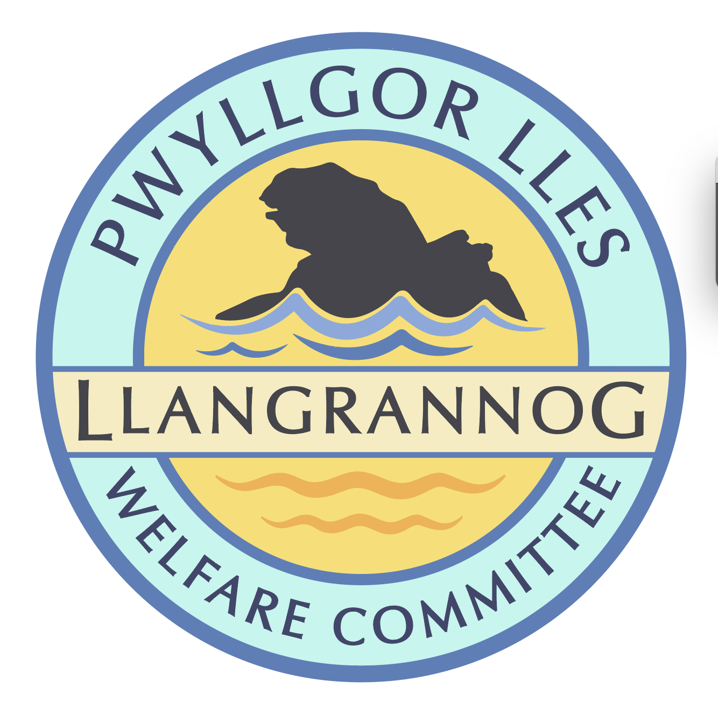
Minutes of the Meeting of the
Pwyllgor Lles Llangrannog Welfare Committee
Thursday 11 October 2025
1. Present: Kat Dawes, Tracey Rix, Jane Lindop, Gerry Jones, Gari Pwyll, Paul Dawes, Clive Bullock, Jez Rix, Adrian Brice, Helena Boyesen, William Riley
2. Apologies: Pob Thomas, Cynyr Ifan, Gail Robinson
Minutes of the September meeting were agreed as correct.
3. Notes arising from Minutes of the September meeting
3.0 Pontgarreg Field. One of the Field benches has been taken to the Hall by Adrian and Gerry.
3.1 Risk assessments. Lime kiln to be done. We have Risk Assessments for St Crannog statue, Ffynon Fair and Garden.
3.2 Rubbish. Big bins were cleaned with the help, water and electricity of Jane Arrow with many thanks. Paul Edwards and team have been thanked for their work over the summer. More stickers for the bins have been requested. The Community Council do not have the bins in their asset list.
3.3 Friends of Llangrannog. There have been quite a few donations especially linked to events/campaigns.
3.4 Duck race. Special thanks to Dewi.
3.5 Railings on the slipway still not fixed. Lucy Prisk (Keep Wales Tidy) has contacted Cliff Bates on our behalf.

3.6 Flags Wales flag. Ongoing. Pole needs a new base.

3.7 Cranogwen/Garden info boards. Ongoing.

3.8 Information boards. Ask Nigel Nicholas (coastal path) The one above Carreg Bica has disappeared. Check who made the board on Pen Rhip and maybe we can have them redone.

3.9 Fundraising. Quiz night Thursday 6th November – ask Mike/Sior We could donate to the National Eisteddfod fundraising effort with the proceeds (first one in Cardigan since 1976).

3.10 Ffynnon Fair. Gate and railings could be installed. It’s about four metres; we’d need four posts and a galvanised gate; around £200. All agreed.

3.11 (3.13) Outfall pipe. Looks worse than ever. There is a break before Carreg yr Adar.

3.12 (3.15) Toilets: Meeting organised with the Council on 20th October. Ongoing. Cynyr and Kat to ask Lowri for a letter of complaint.
3.13 (3.16) River Hawen pollution. Apparently been sorted.
3.14 (3.18) Bench above Carreg Bica. New bench £220. Could be taken down via the Lochtyn quarry path. Gerry and Sarah have made the site ready.

3.15 (4.2) Plaque Application. Approved. Installation costs to include a donation to the village. Plaques cost about £100.

3.16 (4.4) Bench on coastal path looking over Lochtyn island needs a new length of timber on the top.

3.17 (4.5) Christmas Dinner. Ask Mike for a date, check list and produce invitations for next meeting.

3.18 (4.6) Mari Lwyd. We would like to help revive this, involving the youngsters and fundraising.

3.19 (4.7) Free Car Park Field. Gerry and Adrian have filled the large hole in the free car park.

Agenda

4.0 Defibrillator The defib is on the Circuit, so 999 dispatch would tell callers about it if it is needed. We could create a window sticker to allow people to find the info in emergency. Revisit this in the summer: agenda item, put on the Hwb, and in noticeboards. Get agencies like West Wales Homes to email the information to holiday home owners.

4.1 Companies House changes will come into force next year; every director (i.e. member of the Committee) will have to register with the government to prove their identity. Details to follow.

AOB

5.0 Fireworks. Could the fireworks event return? We agreed it would have to be very differently run. We can talk about this further in the New Year. We could have fireworks for the Welfare centenary in 2026? Look for info from old minutes.

5.1 Tracey Rix will be running a shop in the old Gallery/little Shop called Aromist and there will be an opening night before October half term.

5.2 Chris Polytunnels has a half share in Cwm Cou Organics apple pressing machinery and pasteurizing. We could have a pressing day next year; add to calendar.

The meeting closed at 21:20
Next meeting – 13 November, 7:30pm Pentre.

