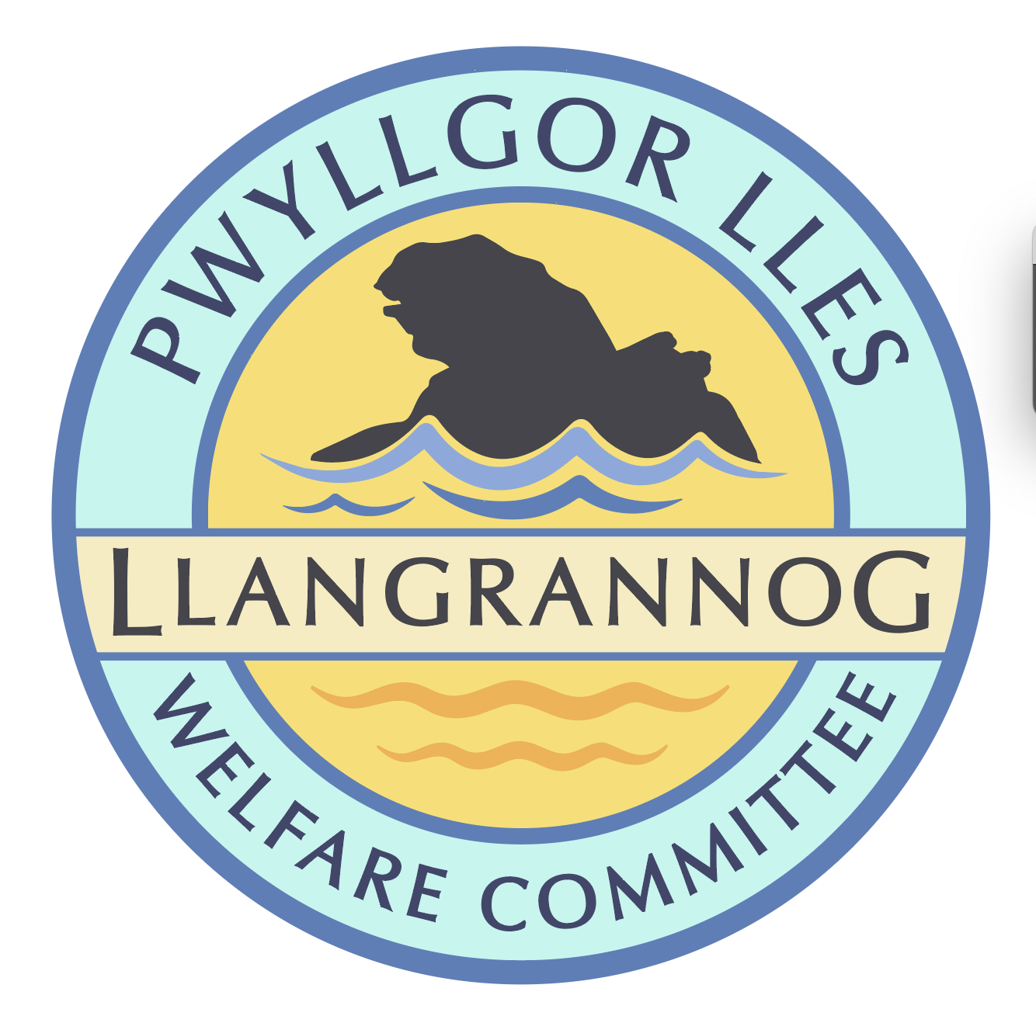
Minutes of the Meeting of the
Pwyllgor Lles Llangrannog Welfare Committee
Thursday 13 November 2025
1. Present: Kat Dawes, Jane Lindop, Gerry Jones, Clive Bullock, Pob Thomas, Cynyr Ifan, Gail Robinson
2. Apologies: Tracey Rix, Gari Pwyll, Paul Dawes, Helena Boyesen, William Riley, Jez Rix, Adrian Brice, Sam Wilmott, Vinny Vincent.
Minutes of the October meeting were agreed as correct.
3. Notes arising from Minutes of the October meeting
3.0 (3.1) Risk assessments. Ongoing.
3.1 (3.2) Rubbish. Pob met with Paul Edwards. The big units have been taken by other communities, but Paul will try to find one for us next year. Aberporth purchased one for £400.
3.3 (3.5) Railings on the slipway still not fixed, although the old ones have been removed. We will ask the Community Council to get in touch as well.

3.4 (3.6) Flags Wales flag. Ongoing.

3.5 (3.7) Cranogwen/Garden info boards. Ongoing.

3.6 (3.8) Information boards coastal path. PT spoke to Nigel Nicholas at Council who will get back to us. Dylan from Gwersyll will ask Lowri if they want to be part of the project. The boards were paid for with WG/EU money, the Discover Ceredigion fund and Cynnal y Cardi.

3.7 (3.9) Fundraising. Quiz night will be rearranged in the New Year.

3.8 (3.10) Ffynnon Fair. Gate and railings. Ongoing.

3.9 (3.12) Toilets. The Community Council met with two Council staff. CC wanted to know more about the expenses involved. The Council are still not saying they will close them. Restructuring in 2027 means Penbryn ward (Tresaith toilets) and Llangrannog wards will be joined into one Community Council; we have to wait until this happens to finally decide.

Llyr from Aberafon has written to the Council concerned that they have not followed correct procedure; we would like to have this information if possible.

3.10 (3.14) Bench above Carreg Bica. Will be ready for delivery soon.

3.11 (3.16) Bench on coastal path looking over Lochtyn island needs a new length of timber on the top.

3.12 (3.17) Christmas Dinner. Wednesday 10 December. Invitations were divided for delivery. We have 40 spaces but over 100 people on the list, so it has to be first come first served, and we have asked that plus-ones are limited as far as possible.

3.13 (3.18) Mari Lwyd. We will discuss further in the next meeting.

3.14 (4.0) Defibrillator. Pauline Bett, a local First Aid instructor, has offered defib training. We will arrange this for early 2026.

AOB
5.0 Crannog’s Cave. We will look at forming a work party to clear the path.

5.1 4Llan (local Community Land Trust) will be at the Coffee Morning in Pontgarreg Village Hall 6th December. They will be discussing ideas for future use of the school field including affordable housing.

5.2 Pentre Christmas Craft Fair is 22 November and Tafell a Tân are holding one on 27th November.

5.3 Christmas Trees. Call Mickey and get trees paid for.

5.4 Church Christmas Tree Festival. We will take part in this event. We will buy a small tree. Every member of the Committee should put something on it.

5.5 Mervyn & Julia Palframan have now retired from Caffi Patio. We will arrange a suitable tribute to mark this.

5.6 Dydd Gŵyl Dewi. Carys Ifan has applied for some funding for planning events for 1 March.
The meeting closed at 21:00
Next meeting – 11 December, 7:30pm Pentre.

