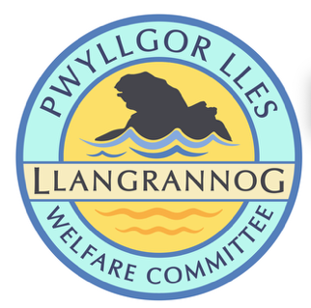
Minutes of the Meeting of the
Pwyllgor Lles Llangrannog Welfare Committee
Thursday 8 January 2026
1. Present: Kat Dawes, Tracey Rix, Gari Pwyll, Adrian Brice, William Riley, Jez Rix, Jane Lindop, Gerry Jones, Cynyr Ifan.
2. Apologies: Pob Thomas, Clive Bullock, Gail Robinson, Vinnie Vincent, Sam Wilmott, Paul Dawes.
Minutes of the December meeting were agreed as correct.
3. Notes arising from Minutes of the December meeting
3.0 Risk assessments
- Cranogwen statue and garden – done thanks GR, HB
- Lime Kiln – GJ, WR
- Orchard – AB, GP
- Fynnon Fair – done thanks JL
- Monthly meetings – CI
- Duck races – TR, JL
- Over 60s Xmas Dinner – KD
- Christmas trees – GP, AB
Remind people a week before the meeting. Penalties will apply!
3.1 Rubbish. Ceredigion Community Grant application to create a rubbish collection point is in process.
3.2 Railings (slipway) Ongoing.

3.3 Flags Flagpole will be removed in better weather.

3.4 Cranogwen/Garden info boards. Now sited; thanks to Helena and Seb Boyesen.

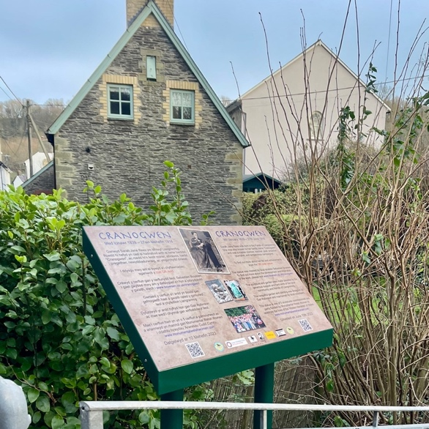

3.5 Information boards coastal path. Ongoing – requires funding. Andrew Gaunt designed them.

3.6 Fundraising. Quiz night – ongoing.
Village Garden Party June 16th to commemorate the unveiling of the Cranogwen statue. Discuss ideas at Feb meeting.

3.7 Fynnon Fair. New gate and railings. Ongoing.

3.8 Toilets. Will be kept open for now with a contribution to running costs from the Community Council.

Email to Llyr Davies (Aberafon) from Russell Hughes-Pickering at the Council states:

The on-going engagement with Town and Community Councils will help inform options for the future provision of public toilets in the County. As previously stated, some Town and Community Councils have responded positively but some haven’t so we will need to consider and consult on a range of options before taking irreversible steps. Engagement with Llangrannog Community Council has been positive. They are unable to take responsibility for the toilets at the present time, but they have offered a small contribution to the running costs. There are no plans to close them.
Moving forwards after the Updated Action Plan is published, the Council will review the Local Toilet Strategy within a year after each ordinary election as is required by Section 113 of the Public Health (Wales) Act 2017.

3.9 Bench above Carreg Bica. Sample plaques for benches etc. have been requested. 35mm ones are 75p or £1.05 (metal effect) and come with two holes. They are engraved so should withstand the elements.

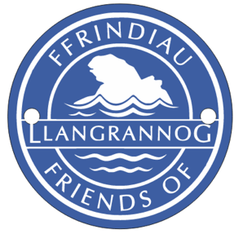

3.10 Leaning Bench on coastal path looking over Ynys Lochtyn. Fix.

3.11 (3.12) Mari Lwyd. Put this on the list to arrange for next year. Find the books etc.

3.12 (3.13) Defibrillator. Free defibrillator and CPR training in Neuadd Goffa Pontgarreg Memorial Hall 29th Jan, 7:30pm. All welcome, no need to book.

Defib check completed today, and the Circuit has been updated. Clive and Kat are the Guardians. New paediatric pads are in.

3.13 (3.14) St Crannog’s Cave. We will look at forming a work party to clear the path in March – check what wood we might need, set a date at next meeting.

3.14 (3.15) Christmas Trees. Brilliant team event: GP, AB, Mickey; extra thanks to Jane and G for additional help. Now needs to come down asap.

We need tough, waterproof and easy-to-erect lights – put this on the list for discussion in October/November. There are options for adding lights to the tree that are less dangerous e.g. a donut topper with lights coming down.

3.15 (3.16) Church Christmas Tree Festival. Won by Sarnau WI and craft group. Trees will be replanted by us if required. Set a reminder for next year.

3.16 (3.17) Mervyn & Julia Palframan. We will arrange a suitable tribute to mark this.

3.17 (3.18) Dydd Gŵyl Dewi. Carys Ifan gave us more information on this successful funding bid. Plans for workshops to make banners etc. with local kids, a band in the Pentre, fundraising for the National Eisteddfod.

3.18 (4.0) Send Tamsin Hayes (Haulfryn) a sympathy card on the passing of her husband Sean.

4.0 AOB

4.0 Cwarae Digging and other work is going on up the quarry. It is reported that they want to build a workshop and some shepherds’ huts. We have not seen any application for planning permission.

4.1 Friends of Llangrannog We have £1,200. We need to focus on signing people up for regular giving. Jez will do some posts for Fb etc. The more pictures we can get and share of the work we do the better; add to WhatsApp group/GDrive. All events e.g. duck races should have a FoLl kit e.g. posters, badges, flyers we can give out. Beer mats, logos on reusable plastic glasses like e.g. Bluestone, Harbourmaster could be very useful. Speak to G or Tom in the Pentre.

4.2 ‘No Sat Nav’ Sign for end of Lôn Cati – we will look into buying one ourselves; the Council have been asked before.

4.3 Trail Champions We were contacted about this Council project and have replied asking for more information. Initiative to get communities to help maintain footpaths etc. They offer some training.

4.4. New bridge for the footpath across the field (Min-y-Nant to Lôn Cati) has been completed by the Council and is very solid.

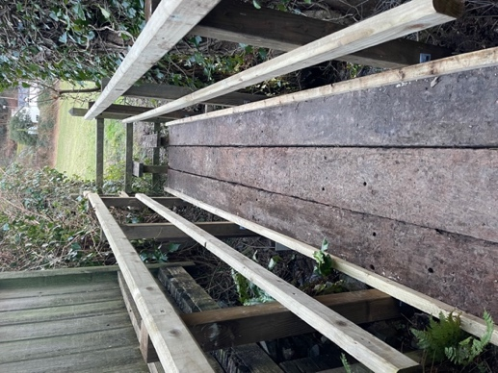

The meeting closed at 20:46
Next meeting – 12 February, 7:30pm Pentre.

