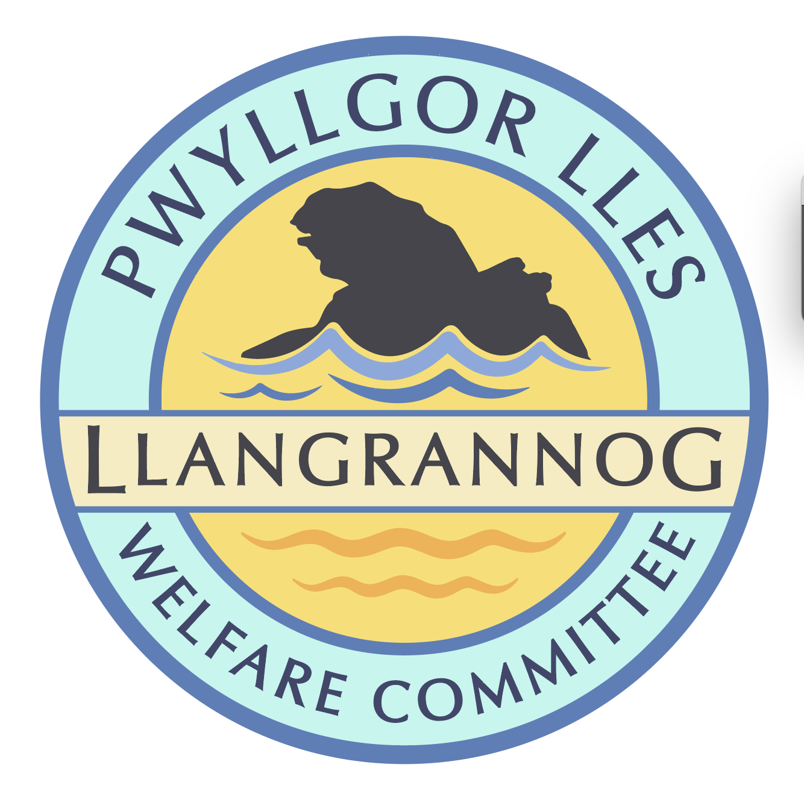
Pwyllgor Lles Llangrannog Welfare Committee
Minutes of the Annual General Meeting
Thursday 8 May 2025 7.00pm
Y Caban/Beach Hut

1. Welcome. The Chair welcomed the members of the Committee.

2. Guest speaker. Paul Edwards from Ceredigion County Council came to speak to us about ideas for rubbish collection in the summer, following on from a meeting last year.

Weekends are covered but the staff are stretched. There are 12 street cleaners for the county; there used to be 6 extra for the summer but there are now only 3. New Quay, Aberporth and Llangrannog are the main hotspots.

There are grants available for the Community Council to employ a litter-picker for the summer months. (This money doesn’t necessarily come from the Council, and they don’t control it.)

We could have a closed shed/compound/big bin up in the car park field – we have the key, whoever does litter-picking leaves it in the shed. Red bags would be good but anything could be used. This could include a seagull-proof bag. We could use dumpy bags for takeaway rubbish/cardboard but not heavy stuff.

We could look at putting the bags into the Park & Ride bus at the end of the day, on a special extra run, as long as the bags are not dirty. Or locals can take it up.

6x4 shed-style thing offered – we could put it by the lime kiln or up in the carpark.

Currently it will be collected by a small cage lorry.

It was noted that the bigger bins don’t suit Llangrannog – they block the pavements.

It is not up to us to empty the bins, but if it needs doing we would have the means to do it.

Paul provided some ‘If it’s full take your litter home’ stickers for the bins.

Paul has asked 4 local schools about a new poster design; we can support this.

Second homes There are two people chasing down all the second home owners and rental businesses who should be paying for rubbish collection — only 700 are registered.

There is a new 3-max black bin bags rule coming out. Lots of people are not recycling but this will help to up the percentage of recycling going on.

Recycling public rubbish
Llangrannog businesses spend a lot on being plastic free, but recycling doesn’t work as only one piece of non-recyclable rubbish contaminates the whole bin. Pilots have proved that it doesn’t work as people do not bother.
Recycling goes into Ireland – cheaper.
We could try to run a little recycling scheme in the car park supported by Paul and look at it if this works here. We could certainly ask for another bottle bin and even a bottle bin down the front.

If we’re proactive and the businesses and Community Council help, we can all help each other.

2. Members present Kat Dawes, Tracey Rix, Jane Lindop, Gerry Jones, Jez Rix, William Riley, Gari Pwyll, Adrian Brice, Paul Dawes, Pob Thomas, Sam Wilmott, Vinny Vincent, Clive Bullock, Gail Robinson, Helena Boyesen, Cynyr Ifan.

3. Apologies – None.

4. Minutes of last AGM’s meeting. Agreed Gail, seconded Clive.

5. Chair’s report – Adrian Brice
The last year has been productive but also fun, with all members bringing something to the table and working as a great team.
More benches, gates and information boards have been actioned and fundraised for. Many thanks especially to Gail and all involved with the garden project and regular action. Clive has a thankless task as Treasurer which is nonetheless essential. We have lot of real movement and plans for the next year, and a good chance of carrying on for some years to come.

6. Treasurer’s Report – Clive Bullock
We have had a quieter year after the garden/statue expenses. We received quite a lot of money in Jan/Feb. The new investment account is making a small amount of money; we could add more to it where possible.

Elections:
What the Welfare does and what being a member entails.
An hour or so meeting every month except August, shared between the different venues in the lower village. Members can then take part in whichever aspects/projects interest them. Our aim is to support the village, residents, businesses and visitors however we can.

7. Election of Committee
Present members standing for re-election: Clive Bullock, Kat Dawes, Paul Dawes,
Gari Jones, Adrian Brice, Gerry Jones, Helena Boyesen, Jeremy Rix, Tracey Rix, Gail Robinson. Cynyr Ifan, Pob Thomas, Vinny Vincent, Pob Thomas, Sam Wilmott, Vinny Vincent, Jane Lindop.

There being no objections, all were re-elected.

8. Election of Officers 2025-2026
Chair Adrian Brice – proposed by Vinne, seconded by Gari.
Vice-Chairman: Gari Pwyll Jones Proposed Helena, seconded Gail.
Secretary: Kat Dawes Proposed Adrian, seconded Clive.
Treasurer: Clive Bullock Proposed Paul, seconded Gari.

Meeting ended 20:56

Next ordinary meeting, 12 June 2025

Diolch yn fawr i bawb.

