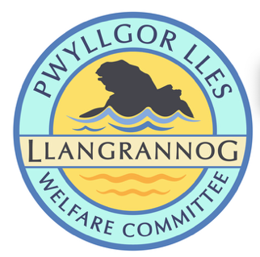

Minutes of the Meeting of the
Pwyllgor Lles Llangrannog Welfare Committee
Thursday 12 Feb 2026
1. Present: Kat Dawes, Tracey Rix, Gari Pwyll, Adrian Brice, William Riley, Jez Rix, Jane Lindop, Gerry Jones, Clive Bullock, Gail Robinson
2. Apologies: Pob Thomas, Cynyr Ifan, Sam Wilmott, Paul Dawes
Minutes of the January meeting were agreed as correct.
3. Notes arising from Minutes of last meeting
3.0 Risk assessments
3.1 Rubbish collection point.
3.2 Railings (slipway) Still broken. More Clic reports from all please. Gari to raise it in the Community Council

3.3 Flags Flagpole has been removed and re-siting is to be planned

3.4 (3.5) Information boards coastal path. Helena/Seb have another stand to put in near the new bench above Carreg Bica. They have cleaned the board itself. A new footing is required

3.5 (3.6) Fundraising. Quiz night – March. We will ask Chris Kelly to do the questions.

Village Garden Party June 16th to commemorate the unveiling of the Cranogwen statue. Agenda item for March meeting; ask local businesses if they would like to be involved. Enquire about using electricity

3.6 (3.7) Fynnon Fair. HB offered to get some small galvanised railings. An information board is planned.

3.7 (3.9) Mini plaques for sites. We would like 45mm, 10 gold 10 blue to start with. We could make keyrings/stickers with this idea.

3.8 (3.10) Leaning Bench. Work completed with thanks to Adrian, Gerry and Sarah.

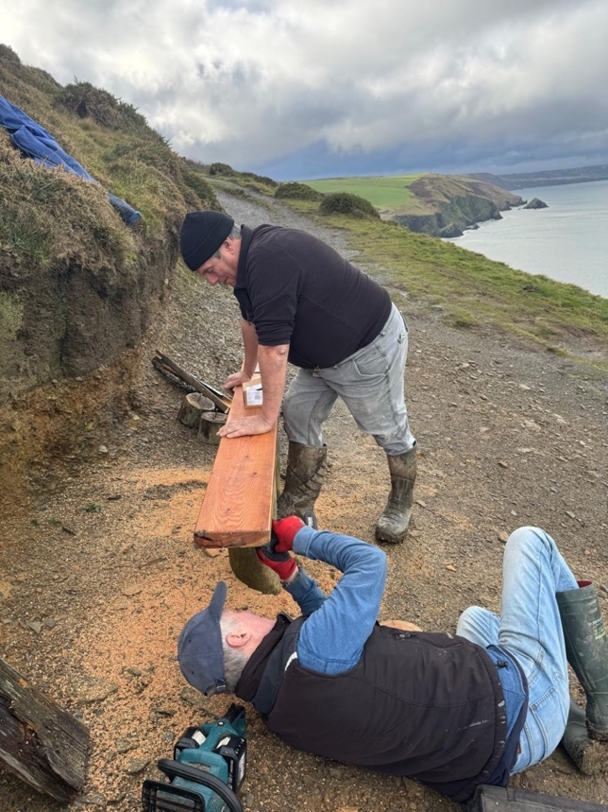

3.9 (3.12) Defibrillator. Free defibrillator and CPR training was held; 24 people attended. Many thanks to Pauline Bett. We will make a donation to the charity which pays her. The Community Council are hoping to place a defib at Pentregat.

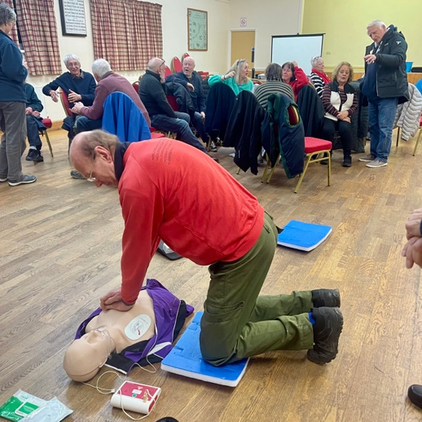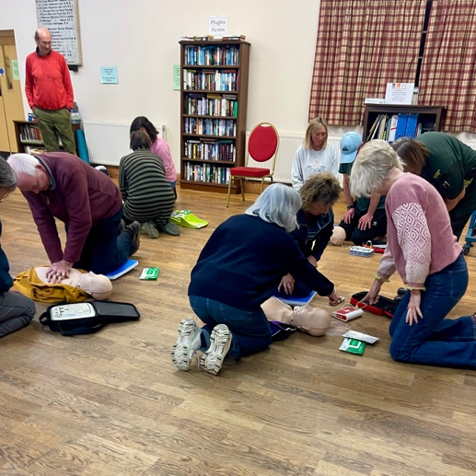

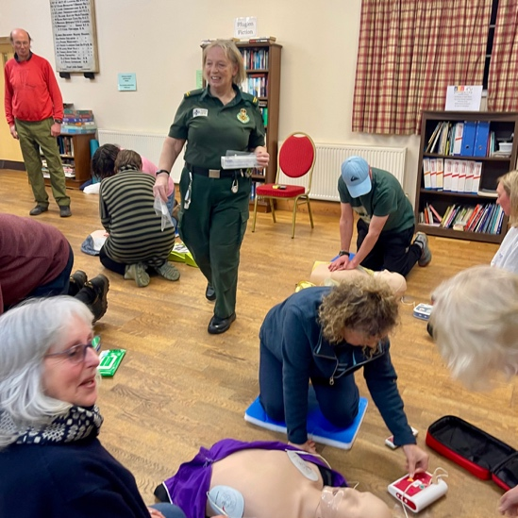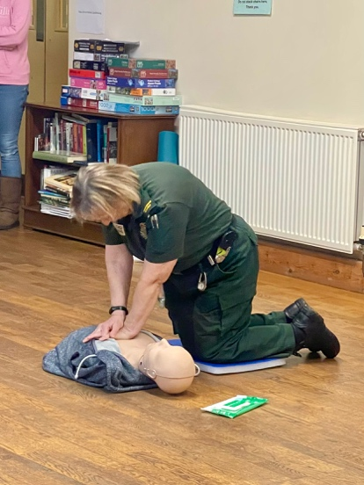

3.10 (3.13) St Crannog’s Cave. We will meet on Sunday 15 March at 10am in the churchyard to strim the path to the cave and assess the condition of steps etc.

3.11 (3.14) Christmas Tree pot. It would be nice to paint the pot and then put a potted plant in it (we can’t fill it with soil).

3.12 (3.16) Mervyn & Julia Palframan. Jane y Graig will present ideas.

3.13 (3.17) Dydd Gŵyl Dewi. Posters are out for the planned events. The banner-making workshop was great. Banners are planned to go up from the Brynhoffnant junction towards Sarnau.

3.14 (4.1) Friends of Llangrannog
Beer mats, logos on reusable plastic glasses. Speak to G or Tom in the Pentre

Jez has created a promo video; Pob has translated. Note that all our ongoing work needs to be photographed, posted and shared. Share to WhatsApp please

3.15 (4.2) ‘Do Not Follow Sat Nav’ Sign for end of Lôn Cati.

3.16 (4.3) Trail Champions Ongoing.

3.17 (4.4) Stile on steep path from Lôn Cati up to Eisteddfa broken. Chat with Steve.

4. AOB
4.0 AGM Ask Jane if we can use the Beach Hut in April.

The meeting closed at 20:43
Next meeting – Thursday 12 March, 7:30pm Pentre.

